Matlab Exercise – 9

**Anusha Garg**

**RA 21110470232**

Polynomial Curve fitting

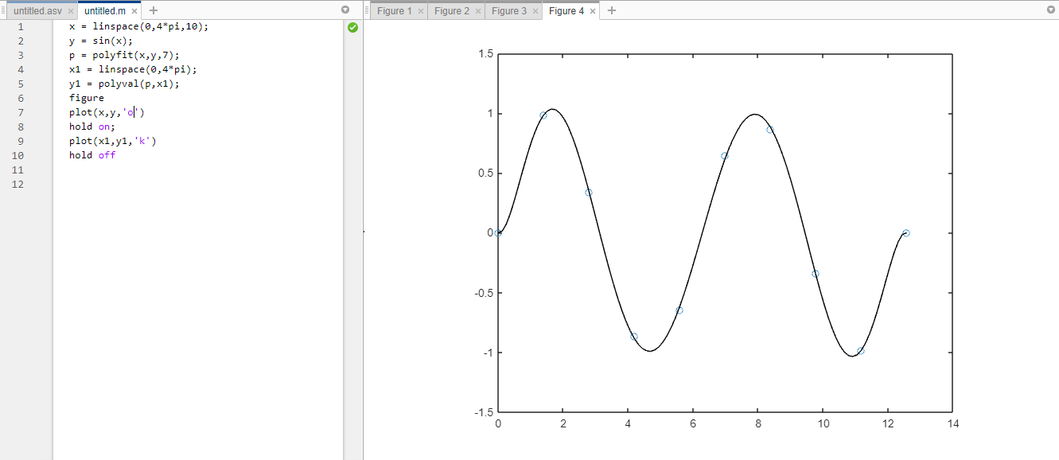

Fzero()

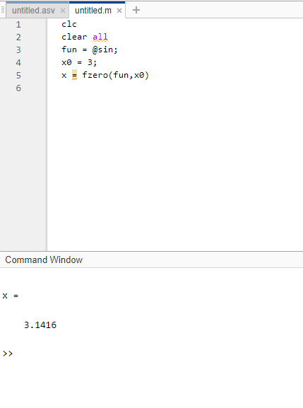

Numerical Differentiation

